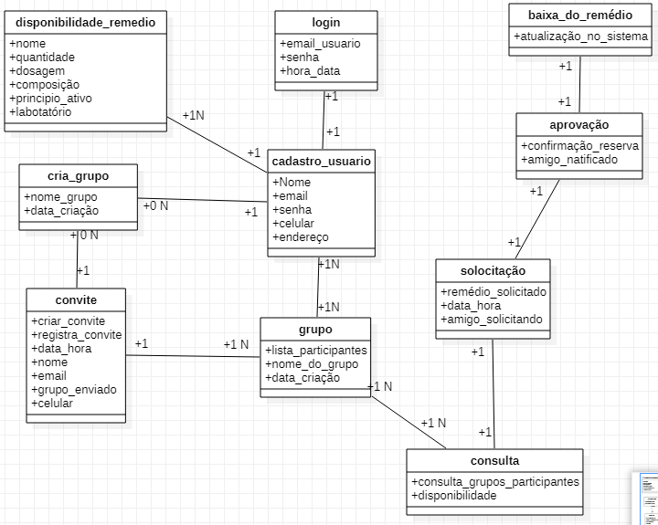

Gabriel Santana Goes RA:819220395